Click chemistry:

**Mechanism of the Copper-Catalyzed Azide-Alkyne Cycloaddition (CuAAC)**

As one of the best click reactions to date, the copper-catalyzed azide-alkyne cycloaddition features an enormous rate acceleration of 107 to 108 compared to the uncatalyzed 1,3-dipolar cycloaddition. It succeeds over a broad temperature range, is insensitive to aqueous conditions and a pH range over 4 to 12, and tolerates a broad range of functional groups. Pure products can be isolated by simple filtration or extraction without the need for chromatography or recrystallization.

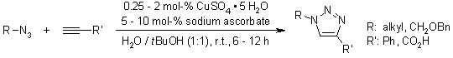  
F. Himo, T. Lovell, R. Hilgraf, V. V. Rostovtsev, L. Noodleman, K. B. Sharpless, V. V. Fokin, *J. Am. Chem. Soc.*, **2005**, *127*, 210-216.

The active Cu(I) catalyst can be generated from Cu(I) salts or Cu(II) salts using sodium ascorbate as the reducing agent. Addition of a slight excess of sodium ascorbate prevents the formation of oxidative homocoupling products. Disproportionation of a Cu(II) salt in presence of a Cu wire can also be used to form active Cu(I).

DFT calculations have shown that coordination of Cu(I) to the alkyne is slightly endothermic in MeCN, but exothermic in water, which is in agreement with an observed rate acceleration in water. However, coordination of Cu to the acetylene does not accelerate a 1,3-dipolar cycloaddition. Such a process has been calculated to be even less favorable than the uncatalyzed 1,3-dipolar cycloaddition. Instead, a copper acetylide forms, after which the azide displaces another ligand and binds to the copper. Then, an unusual six-membered copper(III) metallacycle is formed. The barrier for this process has been calculated to be considerably lower than the one for the uncatalyzed reaction. The calculated rate at room temperature is 1 s-1, which is quite reasonable. Ring contraction to a triazolyl-copper derivative is followed by protonolysis that delivers the triazole product and closes the catalytic cycle.

[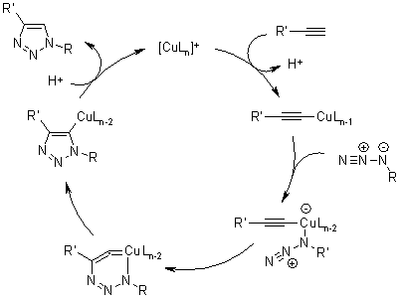](http://www.organic-chemistry.org/abstracts/lit2/773.shtm)  
F. Himo, T. Lovell, R. Hilgraf, V. V. Rostovtsev, L. Noodleman, K. B. Sharpless, V. V. Fokin, *J. Am. Chem. Soc.*, **2005**, *127*, 210-216.